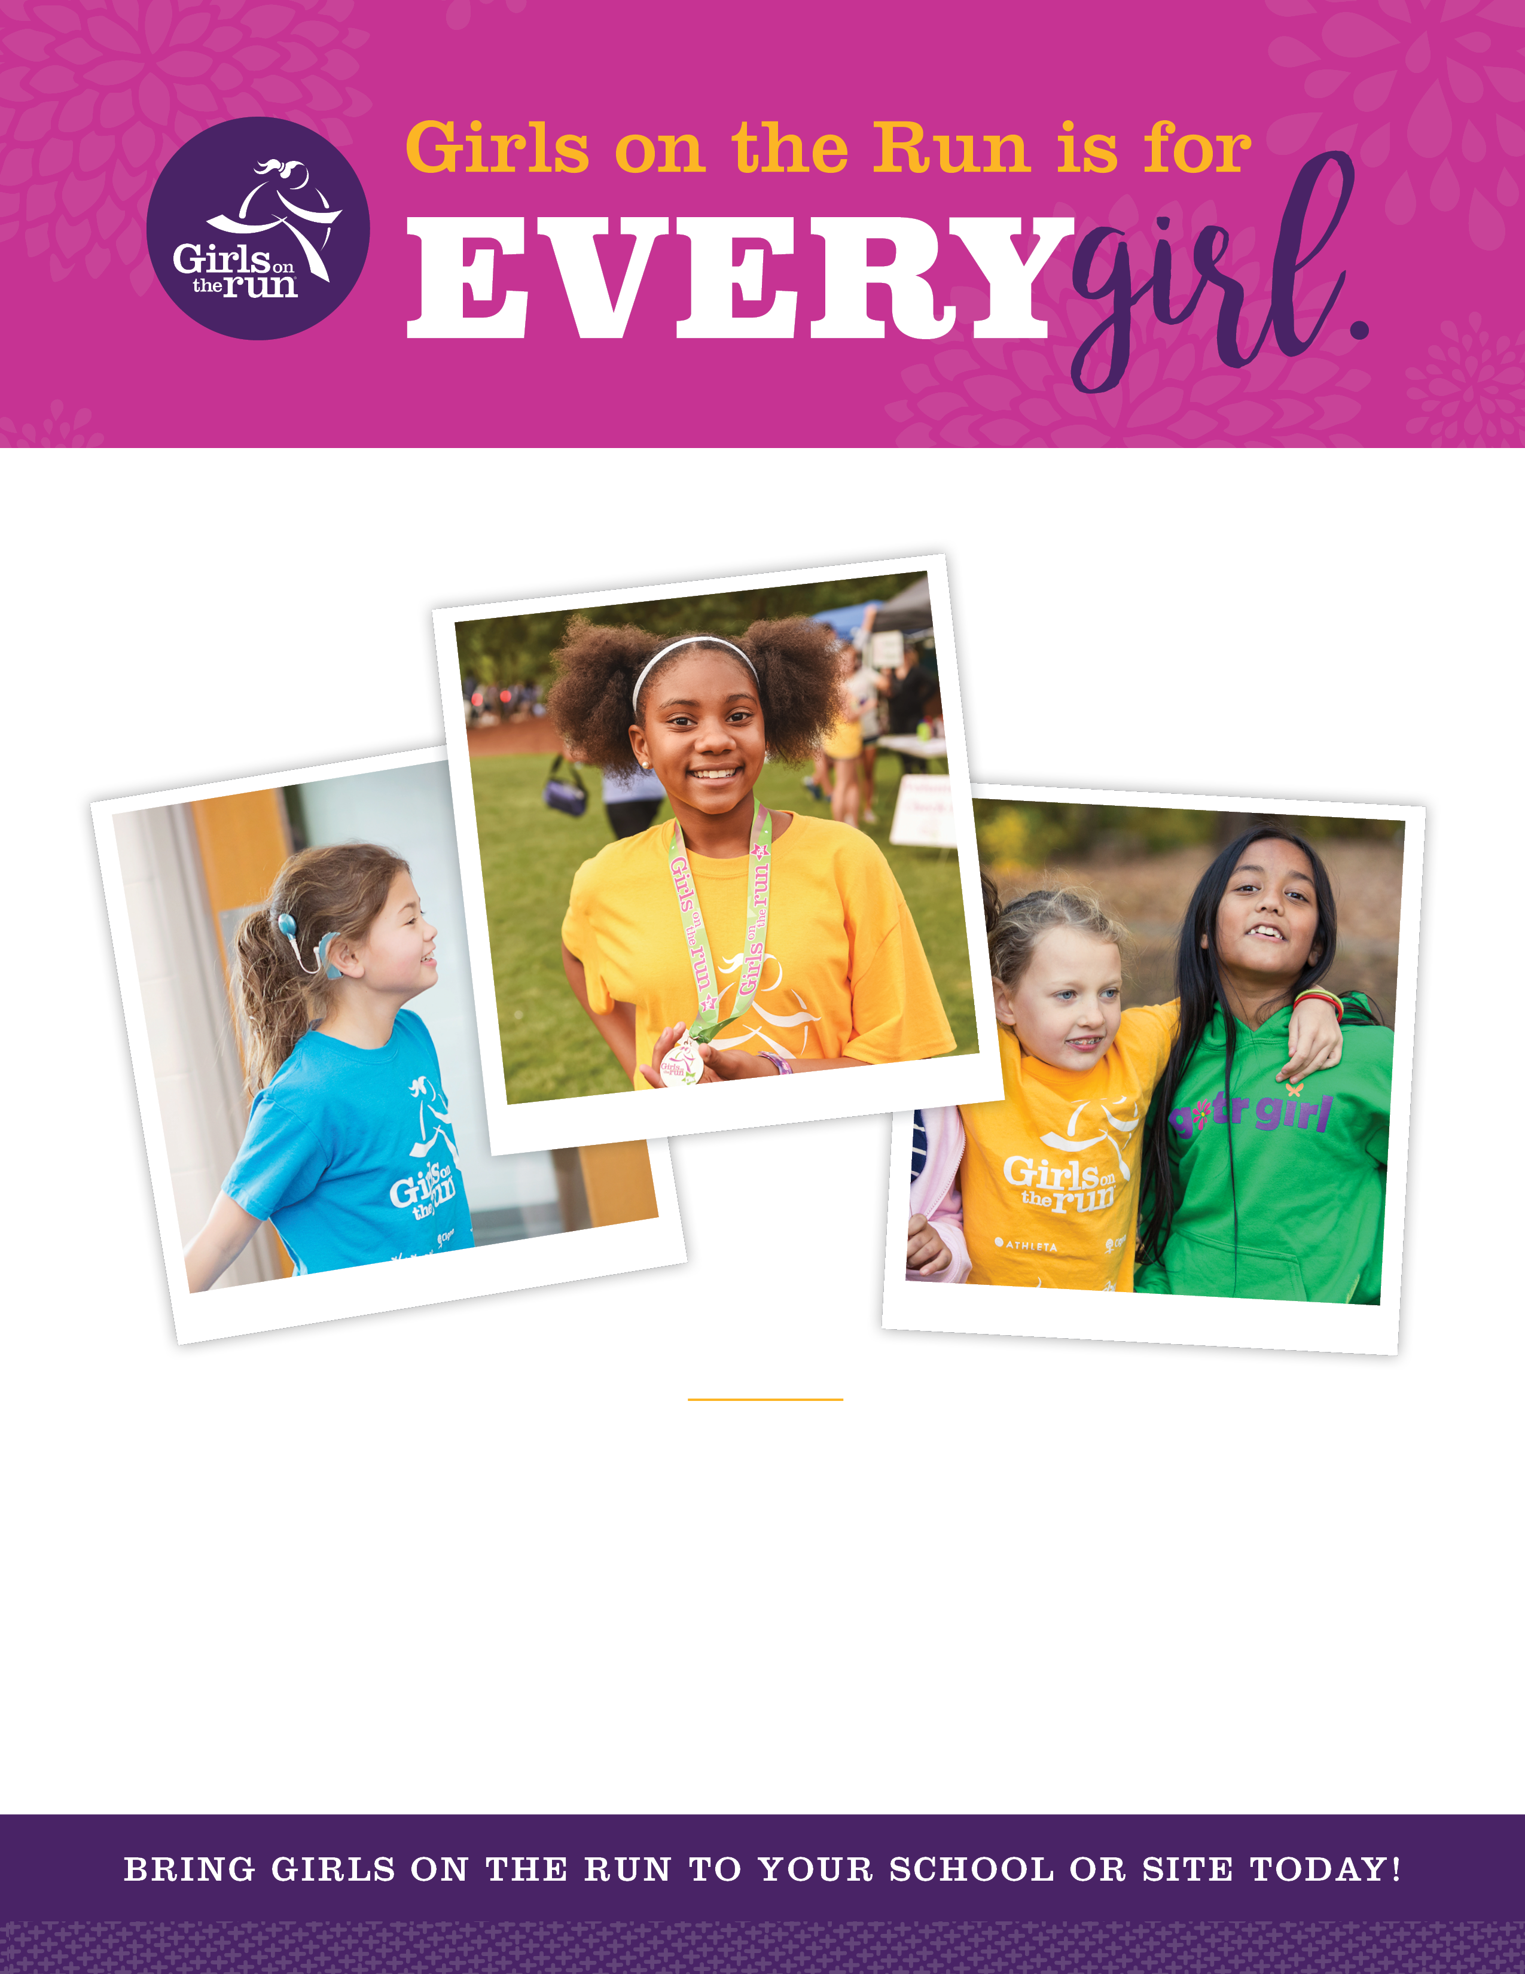
GOTR West Michigan
616-822-5515
Heidi.roberts@girlsontherun.org
www.gotrwm.org

WHO WE ARE

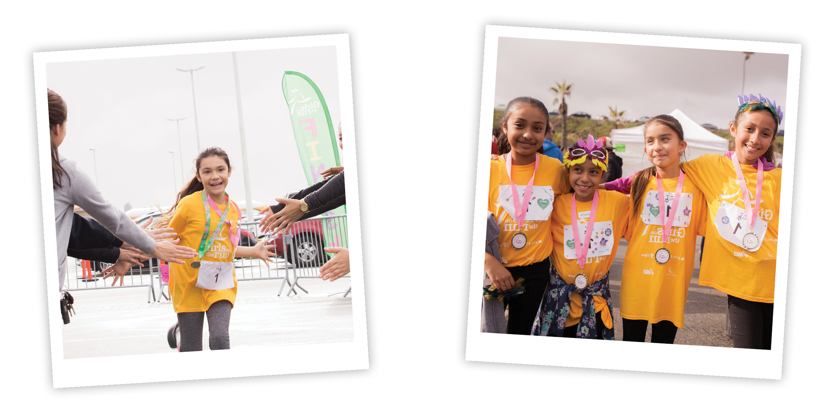

Girls on the Run, a 501c3 nonprofit organization, is dedicated to creating a world where every girl knows and activates her limitless potential and is free to boldly pursue her dreams.

The 10-week program is designed to enhance girls’ social, psychological and physical skills and behaviors to successfully navigate life experiences.

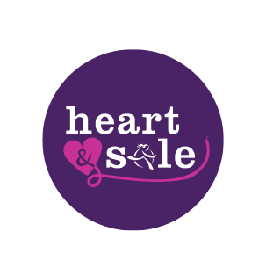
Our Curriculum
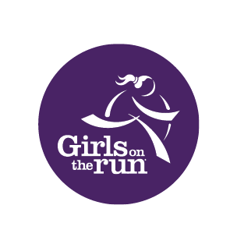

The intentional, inclusive curriculum shows an evidence-based impact on developing competence, confidence, connection, character, caring, and contribution in young girls. Twice per week, trained coaches lead small teams of elementary and middle school girls, including girls with a disability, through life skills lessons that incorporate running and other physical activities.

Physical Activity
- Physical activity - including running and strength & conditioning - is woven into Girls on the Run and Heart & Sole lessons
- At the end of the program all girls complete a noncompetitive, celebratory 5K event that offers girls a tangible sense of goal-setting and achievement
- The program is accessible to all girls regardless ability.

Community Service
- Girls on the Run inspires girls to build lives of purpose and to make meaningful contributions to community and society.
- Girls on the Run participants complete a group Community Impact Project that they plan and execute as a team.
- Heart & Sole participants complete an individual project called Extending the Girl Wheel, where they reach out in small, meaningful ways to an individual or group in their community.

GIRLS ON THE RUN
Elementary Program for 3rd – 5th grade girls

Middle
Elementary Program for 3-5 grade
o Supports girls in gaining a better understanding of who they are, understanding the importance of team work and healthy relationships, and recognizing how they can positively connect with and shape their communities and the world.
o Curriculum themes include: turning negative self-talk into positive self-talk, understanding emotions, standing up for self and others, making and maintaining healthy relationships, and making an impact on the community.

Team Sizes:
- 8-15 girls led by two or more coaches (preferred)
- 16-20 girls led by three or more coaches
- Multiple teams are allowed at a site

HEART & SOLE
Middle School Program for 6th – 8th grade girls

Middle
Elementary Program for 3-5 grade

o Addresses the whole girl – body, brain, heart, spirit, and social connection – and supports girls in building critical life skills such as team building, developing a support system, boundary setting, decision making, positively impacting others, and asking for and providing help.
o Curriculum themes include: getting to know and understand your “Girl Wheel”, goal-setting, overcoming obstacles, asking for and giving help, and positively impacting others.

Team Sizes:
- Recommended team size is 8-12 girls led by two or more coaches
- Up to 15 girls allowed with two or more coaches
- Multiple teams are allowed at a site, with no more than 15 girls on each team

GIRLS ON THE RUN:
COACHES

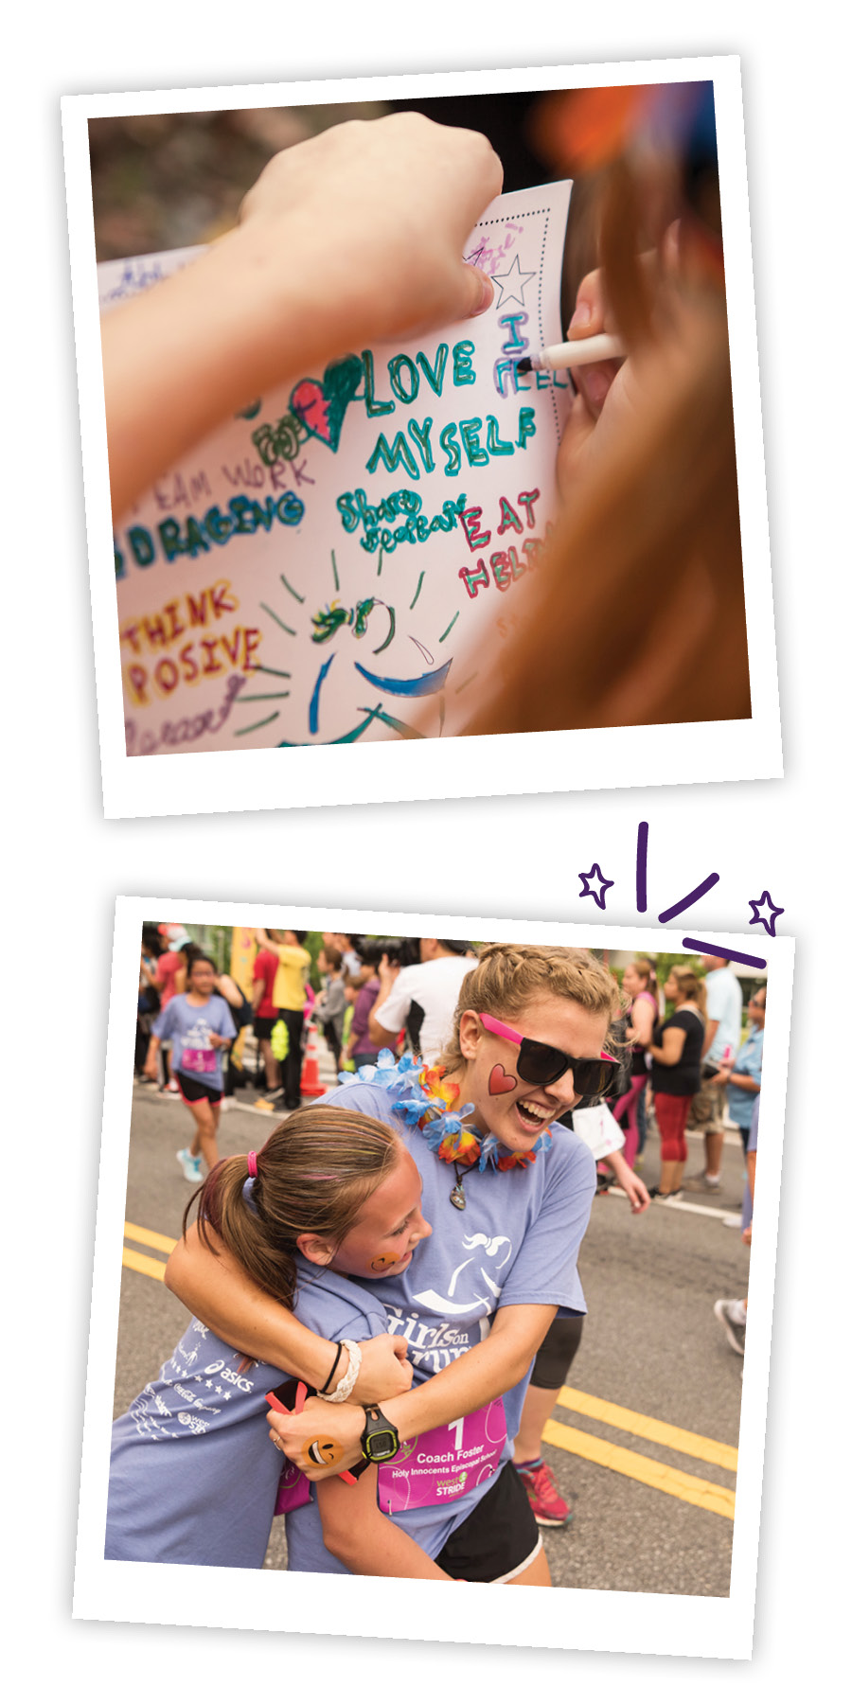
Girls on the Run and Heart & Sole teams are led by volunteer coaches. We train coaches through our National Coach Training to build relationships, create positive inclusive environments and to focus on girls’ efforts and growth.

Coaches:
- Believe in the inherent power within every girl.
- Have a desire to help girls learn, grow and have fun
- Want to leave a lasting impact on the lives of girls in their community
- Can be from within or beyond your site community
- Receive inclusive training and ongoing support from Girls on the Run
- Do not have to be runners or athletes
Coach Responsibilities:

- Serves as a role model to girls
- Attends National Coach Training
- Works with co-coaches to lead girls through the curriculum as intended
- Is present and prepared for each practice
- Participates in the Girls on the Run celebratory 5K event

WHAT SETS GIRLS ON THE RUN APART

IT’S FUN. IT’S EFFECTIVE.

Girls on the Run is the only national physical activity-based positive youth development program for girls with compelling evidence of program impact.

An independent, national longitudinal study conducted in 2016 provided the following evidence-based outcomes:
- 97% of Girls on the Run participants said they learned critical skills to manage emotions, resolve conflict, help others or make intentional decisions
- Girls who were the least active at the start of the program increased their physical activity by more than 40%
- Girls on the Run made a stronger impact on teaching life skills to participants than did organized sports or physical education
INNOVATIVE AND DISTINCT
EVIDENCE-BASED APPROACH
Girls on the Run was recognized in Harvard University’s 2017 report Navigating SEL from the Inside Out for its innovative and distinct approach to social emotional learning. Girls on the Run was one of only three afterschool programs recognized as a top research-based social emotional learning program, acknowledging that there are few examples of evidence-based programs like Girls on the Run that have been specifically designed for out-of-school time contexts.
- Girls on the Run has served over 1.4 million girls since it was founded in 1996.

- Over 200,000 girls in all 50 states experience the power of our transformational program every school year

- Girls on the Run West Michigan started in 2010.
  - Over 25,000 girls have been served since our first season
  - Our sites represent over 100 schools in Kent, Muskegon and Ottawa Counties
  - ALL girls receive a discounted program fee in relation to actual program costs and 50% receive additional program fee support

Support Provided by Girls on the Run

Girls on the Run West Michigan is committed to the success of each site. We are invested in building a long-term relationship to ensure that your girls have an opportunity to benefit from our transformational program. With this in mind, we provide the following robust support:
• Marketing and registration materials to support girl recruitment and registration
• National Coach Training (led by trained facilitators) for all Girls on the Run coaches as well as American Red Cross CPR training for eligible Coaches
• All materials for coaches to carry-out curriculum as-intended
• Girls on the Run t-shirt, personal journal, entry into 5K for all girls along with a 5K shirt and finisher’s medal
• Ongoing support to site liaisons, coaches, and families through regular communication and responsiveness to individual concerns
A National Movement with a Growing Local Presence
HOSTING THE PROGRAM AT YOUR SITE

To host a team, sites must:
- Offer a safe outdoor place for running (such as a track, soccer field, or any other accessible open space)

- Provide a designated accessible indoor space for Girls on the Run to meet in case of inclement weather (such as a gym, cafeteria, multi-purpose room or classroom) and accessible bathrooms

- Accommodate a regular practice schedule (twice a week for 75-90 minutes), according to the Girls on the Run program calendar

- Assist in identifying a site liaison

Site Liaison Responsibilities
- Acts as the main contact at the site for Girls on the Run families/participants and Girls on the Run council staff before and throughout the program.

- Aids in girl recruitment efforts by posting marketing materials (provided by Girls on the Run) and spreading the word about Girls on the Run throughout the site community

- Offers support to families who need assistance in registering their girl

- Helps identify 2-3 coaches from your site and/or community*
*If you cannot secure coaches we will work with you to identify coaches from our volunteer pool

“As a new site liaison, I wasn’t sure about being able to run the program in my school, but I felt supported and encouraged by the GOTR-WM staff and was so glad I was able to offer this life changing program to the girls at my school!”
---GOTR Site Liaison
Our current program fee is $125 per girl. This includes:
- 10 weeks/20 lessons led by trained coaches
- All curriculum materials including a personalized journal for each girl
- Girls on the Run and Heart & Sole Program t-shirts
- Registration for Girls on the Run 5K event along with a 5K shirt and finisher’s medal
Financial assistance is available to any girl who cannot pay the full registration fee. Girls on the Run West Michigan is committed to being accessible to any girl who wants to participate and we are dedicated to ensuring that program cost is never a barrier to participation.
- Financial assistance is available to all girls due to the generous support of local and national funders. We use a sliding scale, based on participant reported household size and income, to determine the discounted rate for each girl. Families are also able to set up payment plans if needed. We are also willing to work with sites to provide a cash option for families unable to pay using cash/check.

Program Cost and Financial Assistance
Next Steps:
- Complete Site Application (all applications due by November 1)
- Attend a virtual Site Liaison Meeting
- Begin promoting the program!

Dates to Remember:
- Spring program starts:
-Muskegon County-Week of February 13
-Kent County-Week of February 27
-Ottawa County-Week of March 13
- Celebratory 5K Event Date:
  - Muskegon County-May 13
  - Kent County-May 20
  - Ottawa County-June 3

